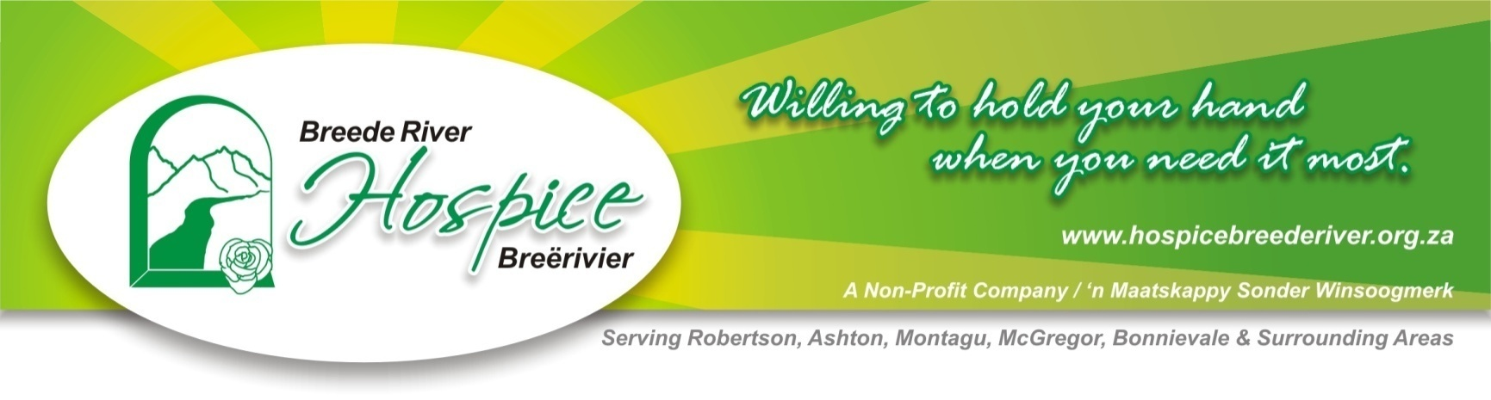

Media Release Date: Wednesday, 12 February, 2014
For Immediate Publication, (please).

1 Woman, 650 Kilometres, 15 Days... - For 1 Great Cause.

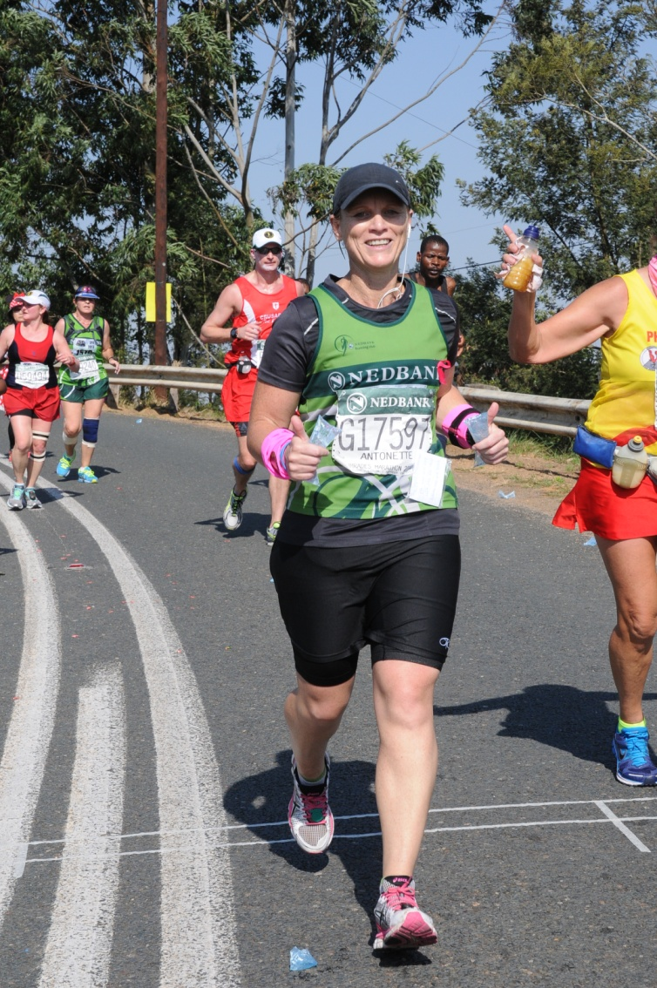
Robertson, Western Cape - Wednesday, 12 February 2014 - A Robertson resident and acknowledged long-distance marathon runner, Antonette Greenaway, is taking on her most gruelling marathon and challenge yet - all in aid of Breede River Hospice - in recognition of the incredible, soul-touching work they do throughout the Langeberg region.

What is likely to be the first feat of its kind to be taken on by a single South African woman, Ms. Greenaway will start off in Port Elizabeth and head home to Robertson via the famous Route 62. Dubbed the “Run Route 62 - Have a Heart for Hospice” Marathon, this is one huge undertaking that is worth every bit of attention it can draw.

Ms. Greenaway and her father, Mr Johann Steyn, were deeply touched and uplifted by Breede River Hospice last year during her mother’s end-stage illness. Since her mother’s passing, she has vowed to do something ‘outstanding’ to bring recognition to the Breede River Hospice ‘hearts’ that stood by her, her father and her mother throughout the most difficult time of their lives. In her own words, “...ek dink nie daar word genoeg dankie gesê vir die werk wat julle mensies doen nie.” (“I don’t think enough thanks is ever given for the work you people do.”)

Breede River Hospice in Robertson is a community ‘beacon’ of hope and support that provides their services entirely for free. Beyond caring for terminally- and chronically ill patients, they reach far deeper into their local community providing a whole range of home based care and support services. These include TB/HIV-Aids Prevention, Counselling and Support, private nursing care, ‘Mother and Child’ care, Child and Adolescent Health and Nutritional Support to name a few.

Breede River Hospice carries a 5-Star Certification from the Hospice Palliative Care Association of SA (HPCA) - one of only 23 hospices in South Africa to do so. They have also been awarded a 3-Year Accreditation from The Council for Health Service Accreditation in SA (COHSASA) for the third time in succession. They are a recognised community training centre providing HPCA and Health and Welfare SETA accredited courses. Through these courses, the BRH trains local care-givers with the skills required to provide essential care-giving and support services to their communities on a grass roots level.
Antonette’s immense effort is entirely dedicated towards raising funds for Breede River Hospice which has, over the last few years, suffered crippling cut-backs in international and local funding. In their effort to save the organisation from collapse, they continually struggle to find new funding to support them - in the face of increasing patient numbers.

Antonette’s goal is “to raise as much money as possible to help towards sustaining this amazing organisation.” In her call to everyone who might listen or take note, she asks any and everyone, including the media, corporate companies, people at home and people on the street to pledge any amount - from 10 cents to R10 per kilometre... and even more, if you’re prepared ‘to go the extra mile’.” (See last paragraph.)

When asked for comment, Sr. Jane Phillips, BRH’s general manager said, “We believe that all patients have the right to die pain free, be cared for with dignity in the comfort of their home and with the family being well supported. The passing of a loved one is a process that affects the whole family and the way a loved one lives the last weeks of his or her life influences the ability of the family to grieve, remember and moved forward at their own pace.

“That Antonette is going to such lengths to create awareness and raise much needed funding for us, leaves us speechless. - We will be behind her all the way and will most certainly make the effort to run the last length with her to the finishing post - at the Robertson Golf Club. We would love to see the whole of Montagu, Ashton, Robertson and everyone else along the way to come out and applaud her. - She really, REALLY does deserve all due recognition for her incredible strength and endurance... - Thank you, Antonette... Thank you.”

Antonette Greenaway is a long-standing member of the Nedbank Runner’s Club and represents the Boland in national long-distance marathons country wide. She has participated in several respected endurance races: The Comrades, the Two-Oceans and the Safari Half-Marathon just to mention a few. This ‘Run Route 62’ Marathon will the longest distance she has ever faced.

Ms. Greenaway promises day-by-day accounts of her enduring experiences to be published on her blog ‘Run Route 62’ which will posted to Breede River Hospice’s Facebook page. A Facebook events page has also been set-up for all followers to ‘attend’ and keep pace with her along the way. To follow her story, simply ‘Like’ Breede River Hospice’s Facebook page to ‘tune in’. A route map together with details of her expected arrival/departure schedule will be published online on her blog for anyone to keep pace with her.

Since she announced her intention only last week, several supporting teams and associations have already committed to her cause. Harley Davidson in Cape Town and the Breede River HOG Chapter - both known for their charity motorcycle drives have promised their support - with a convoy of motorbikes keeping the road ahead clear for her - from Montagu to Robertson.

Sponsorships can be either ‘Rate per Kilometre’ or ‘Once Off’ Donations. To add your pound’s worth to this truly worthy cause, please contact Charmaine at Breede River Hospice on Tel: 023 626 5710 - or email: events@hospicebreederiver.org.za. Sponsorship forms can be emailed or downloaded from their Facebook page.

(930 Words - To be cut and edited as required.)

Author: Mitch Clayton-Cragg
BRH Media & Communications Co-ordinator
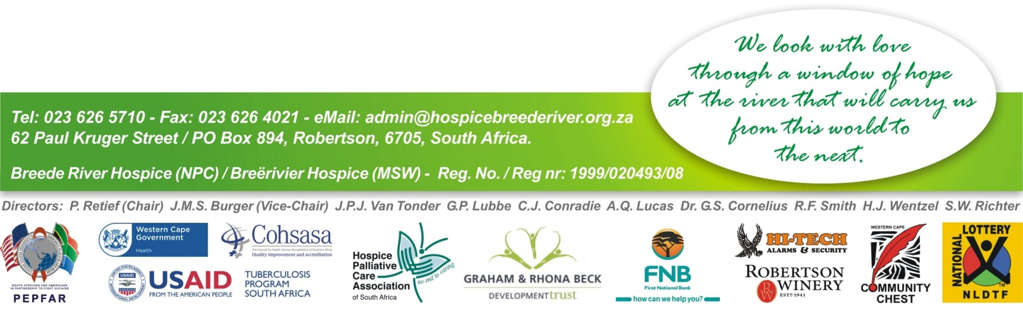
Cell: 076 454 0778

