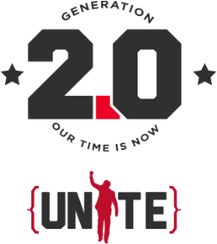
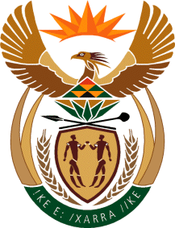
Sport & recreation
Department:
Sport and Recreation South Africa
REPUBLIC OF SOUTH AFRICA

MEDIA RELEASE

SA CABINET MEMBERS #UNITE4MANDELA IN SUPPORT OF THE UNITE 2.0 NELSON MANDELA SPORT AND CULTURE DAY 2014

Johannesburg, South Africa (22 October 2014) – On 22 October, 2014 Members of the South African Cabinet banded together outside the Tynhuys, Cape Town in what can be deemed as one of the greatest show of Unity, in honour of the late President Nelson Mandela.

The cabinet members gathered for a photo in the garden of the Tuynhuys Presidential House in Cape Town, all wearing their UNITE 2.0 campaign t-shirts to pledge and show support for this year’s Nelson Mandela Sport and Culture Day.

With its objectives aimed at Social Cohesion, Nation Building and UNITY, the UNITE 2.0 Nelson Mandela Sport and Culture Day was initiated to bring South Africans together to demonstrate the depth of South Africans' commitment to the late President Nelson Mandela's vision of sports and culture as a nation builder and a unifying force for a cohesive society.

Spearheaded by the Department of Sport and Recreation and the Department of Arts and Culture, the 2014 Nelson Mandela Sport and Culture Day also aims to mobilise the youth. UNITE 2.0 is a call to action for South Africa’s youth, as the generation charged with living the Mandela Legacy, to Unite in building a brighter future for all.

In partnership with Cycling SA and Athletics SA, UNITE 2.0 proudly announces two new sporting codes as the focus for the 2014 Nelson Mandela Sport and Culture Day. The day’s sporting events will feature a cycling race, a road running race, a run/walk race, and a fun walk, which will precede a cultural program, that will include a music concert featuring SA’s icons in the entertainment sector, to be announced by the Minister of Arts and Culture early November.

“The Nelson Mandela Sport and Culture Day is designed to bring together South Africans from all walks of life, particularly this year in its 2nd year and as we celebrate 20 years of freedom and democracy. Almost 1 year ago, South Africans lined the streets of Tshwane, to say our final farewell. This year, on Nelson Mandela Sport & Culture day - we reclaim those very same streets to celebrate the life of this global icon.” says Fikile Mbalula, Minister of Sport and Recreation, South Africa.

In remembrance of the 67 years Mandela devoted to social activism the 67km cycling race will start and finish at the Union Buildings, with the route passing by many historical landmarks and monuments.

There will be cash prizes for the top finishers for all events, with the winners of the cycling road race receiving R150 000, whilst the charity of their choice receives R50 000.

The 27km Road Running challenge winner will also receive R100 000, whilst the charity of their choice receives R50 000. The distance of this race is in commemoration of the 27 years Mandela spent in prison.

The 9.4km Road Running/Walking Events are in remembrance of the 94 years of Madiba’s life. Winners from this category will win R25 000, while his/her charity will receive R15 000 and the 9.4km Walking event winner will receive R15 000, with R7 000 going to the charity of their choice.

Registration for all of these events is now open, and you can sign up online: www.unite4mandela.co.za

Registration Fees:
67km Cycle: R250
27km Run: R70
9.4km Run: R50
5km Fun Walk: R40

THE UNiTE4Mandela CAMPAIGN

Given the historic nature of this event, it is being accompanied by a mass mobilisation campaign involving nearly all public service and commercial broadcast media in South Africa, billboards and social media.

The UNITE 2.0 is a joint initiative by the Department of Sport and Recreation and the Department of Arts and Culture to promote social cohesion and nation building. This program builds on the work, which the two departments had already begun to utilize the power of sport and arts as a formidable tool for nation building and social mobilization. Its fundamental message is a call for South Africans to UNITE.

ABOUT UNITE 2.0:
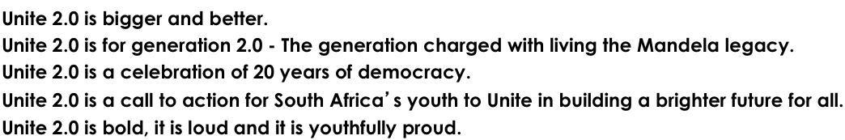

For more information contact:

WEBSITE & SOCIAL MEDIA NETWORKS
www.unite4mandela.co.za
www.facebook.com/UNiTE4Mandela
www.twitter.com/UNiTE4Mandela
www.youtube.com/UNiTEMandela

MEDIA LIAISON & PUBLICITY
ON POINT PR
Vista Kalipa Nicole Ogle
W: 011 482 6155 011 4826155
E: vista@onpointpr.co.za nicole@onpointpr.co.za
M: 076 047 1355 072 336 2739

67km Cycle Race:
1st Prize: R150 000 to winner, R50 000 to charity of choice
2nd Prize: R100 000 to winner, R25 000 to charity of choice
3rd Prize: R75 000 to winner, R10 000 to charity of choice
4th Prize: R5 000 to all Gold Winners

27km Road Running:
1st Prize: R100 000 to winner, R50 000 to charity of choice
2nd Prize: R75 000 to winner, R25 000 to charity of choice
3rd Prize: R40 000 to winner, R10 000 to charity of choice
4th Prize: R5 000 to all Gold Winners

9.4km Road Running:
1st Prize: R25 000 to winner, R15 000 to charity of choice
2nd Prize: R15 000 to winner, R10 000 to charity of choice
3rd Prize: R10 000 to winner, R5 000 to charity of choice

9.4km Walking:
1st Prize: R15 000 to winner, R5 000 to charity of choice
2nd Prize: R10 000 to winner, R3 000 to charity of choice
3rd Prize: R5 000 to winner, R2 000 to charity of choice

CAMPAIGN PARTNERS

- Department of Sport and Recreation
- Department of Arts & Culture
- The Gauteng Department of Sports, Arts, Culture and Recreation
- City of Tshwane
- Cycling South Africa (CSA)
- Athletics South Africa (ASA)
- SABC TV & Radio
- Supersport

