1 Imp

2 Guys

3 Continents

14,000 Kilometres

In less than 40 days!

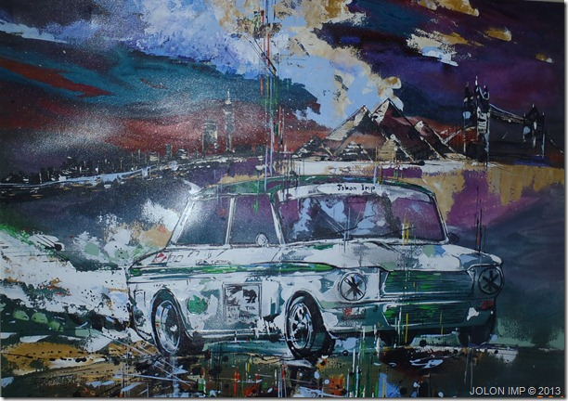

Please vote for this South African built car and help us to win the British Classic Car of the Year.

To vote go to <http://www.ccoty.co.uk/bgbt_voting.php>

On March 28 Geoff Biermann and I decided to present a South African built Hillman Imp at the 50th birthday celebrations of the Imp that was being organised in Coventry, England. In fact what the road trip did show us was a very expensive way to get to England!

The car was stripped bare and fully rebuilt with a few modest mods to tolerate the punishment of the African roads. Higher springs, longer shocks, truck tyres and taller wheel rims all contributed to the upgrade. A big thanks to Roger Pearce for his invaluable advice on both technical and route information.

The rear seats were traded for extra luggage space, which was mostly for tools and spares as one can imagine taking a half century car through three continents. This was more a necessity than a luxury. A skid plate to protect the gearbox and sump was hastily slapped on two nights before we departed. This was yet another last minute task that was undertaken to make the Imp Africa-ready.

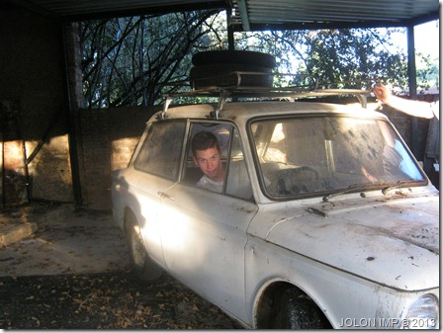

Imp dragged out of its hiding place to begin the rebuild April 2011.

Joburg was left behind with both Geoff and I in high spirits but with a generous amount of trepidation on a number of counts. The car was not properly tested before the journey, actually it was only finally put together a few days prior to our departure and NEVER actually tested. in fact the engine that I had earmarked for the trip was a very nicely built curly edge 875 that had been run and well tested in my race imp a few years earlier but due to licencing issues we had to run with the engine of the Imp that i had driven with complete abandon for about 8 years and whose engine was both burning oil as well as pumping oil out of the dipstick probably due to a build-up of sump pressure. This was also a standard and curly edge block. Now to start out in a set up like that was not necessarily the cleverest plan but it was a plan nonetheless. Lulled into false hope we began enjoying the journey tripping along the billiard table smooth roads of South Africa, sending happy messages to friends and family as we passed meaningful landmarks.

“now passing Midrand, yay!”

“wow, we’ve reached Pretoria!!!”

“just turned west towards Molie Molie”

Believe me, even though these milestones were hardly 150 kilometres from our home they were nonetheless as important as the final leg of the most amazing drive we have ever undertaken.

Incidentally with all going tickety boo as we motored along on our first night drive we suddenly had complete power failure. No engine, no headlights and no idea. In a flash (‘scuse the pun) I had the Streamlight knucklehead out the open window offering just enough light for us to safely bring the car to a stop on the side of the, luckily quiet, country road. With all our headlights and extra spots on full beam, the fuse box simply melted around the fuse that was holding all the aces of power. For a while we assumed it was just another load-shedding effort by City Power. Ten minutes and our first roadside repair was sorted and we were mobile again but this time with no brights or spots which vastly reduced out vision. However since we had a very second-hand 875cc Imp engine delivering horsepower we barely had enough speed to become worried. Unconcerned we were, that was until we hit the first pothole; thump, ouch! NOT GOOD, and so early in the trip!

Well if the engine of the Impi was tired by the time we arrived at the South African Botswana border at Martin’s Drift it needn’t have worried much because it was about to have a major, albeit forced, rest. It took us over 5 hours to get through the border checkpoint. At the late hour of 04h00 we finally managed to extricate ourselves from the immigration stampede and found our way to the local campsite and within minutes we were camped and asleep.

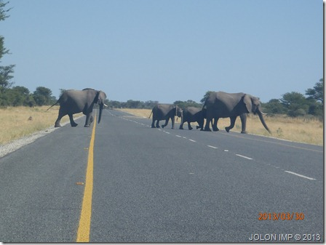

Not Zebra crossing! Chobe National Park Botswana.

Zambia and Tanzania seemed to us to have serious competition of who can produce the most road fatalities as a result of truck and bus accidents. We encountered an inordinate number of wrecks along the roads of both countries. Thankfully they all missed us and our tiny Imp.

A wonderful ice breaker and super focus diverter for us was the map of Africa with our planned route that we had stuck on the bonnet of the car. So before the police at the innumerate checkpoints got too involved in our paperwork we chatted to them about our massive journey ahead. In fact our ploy never failed and through the twenty countries that we traversed we paid not one red cent in bribe money!

Along the early part of the trip we had a few minor technical issues but nothing to write home about, so we didn’t write home! Border formalities were time consuming, expensive and bothersome but with all our paperwork in order we were able to soldier on reward-less.

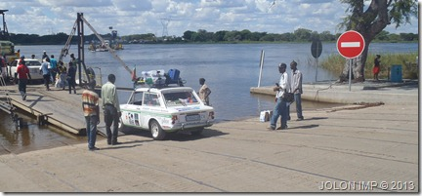

Foreground Botswana, right in background, Zimbabwe and straight ahead, Zambia.

An interesting failure that our car suffered as we departed Johannesburg was the loss of reverse gear! We looked on this as a good omen and interpreted it as a sign that no matter how tough the going would get, there would be NO going back! It worked; we overcame a multitude of meaningful challenges and realised our dream.

Kenya had a road commonly known as the Hell road. Let it be known the name is as apt an appellation as you can get! First and foremost it is populated with bandits that feel no qualms about killing innocent folk who do nothing except to try and hold on to their possessions as they travel from Nanyuki to Moyale on the Kenya/Ethiopia border. The Chinese road crews are hard at work converting the 500 kilometres of gravel track into a fine wide highway. Roll on China!

The Hell road is a desperate track at best and in the dry season (which is most always – North Kenya is lucky to enjoy a few scattered days rain every two to five years) However, in the wet the road is no longer a road and the quagmire riddled landscape becomes all but impassable. Due to extreme weather we were holed up for almost a full week in Nairobi due to the fact that the Nanyuki to Moyale track was a muddy mess with trucks, busses and cars of all sorts stuck solid without hope of rescue.

An excerpt from my blog puts into perspective what we were faced with and how we dealt with it!

***To tackle the Road in north Kenya to Moyale in the dry season in anything short of the best 4 X 4 is insane, to attempt it in the wet season impossible and to dream of doing it in am Imp is certified insanity! Well Geoff and I had a date with destiny in Coventry and nothing was big enough to bar our progress. For Geoff and I who had begun our trip with the end in mind, the impossible was only something that would just delay us a tad, but stop us; NEVER!***

***The Hell road tried hard – the twenty kilometres from our forced two day roadside camp to Turbi village on the north Kenyan desert that was now a verdant mudflat, took us no less than 5 hours of hard toil!***

***A fellow stranded traveller who had to abandon his truck hired a land cruiser and offered to assist un on our way to Moyale. Here is what transpired.***

***Being towed behind the Toyota Landcruiser through the first mud bath was dealt with quite easily and as we exited the hurdle we unhitched the Cruiser and went back to Imp steam. The Cruiser following close and watchfully behind. Geoff was in his element flicking the nimble Imp through the various little mud baths and then riding with one wheel up on the fast drying massive mud ridges left by the articulated and double and triple axel trucks so as not to cause too much damage to the underside of the car. I was excitedly whooping and lauding him on his consummate off-road driving skills as he sped through the easy spots and brought it down to crawling pace for the tricky bits and when the going got too sticky he would resign gracefully and have Eddie line up the Toyota while Terence hopped out IN THE MUD AND FLOOD to hitch up the readymade tow hitch which was gathered loosely in the passenger front footwell.***

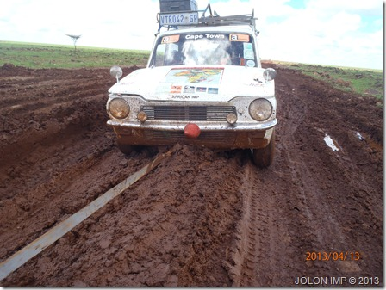

***Our happiness soon turned to deep worry. We had managed to get through some quite tricky areas with the help of Eddie’s consummate skill as a 4x4 driver and skilful tow-master but we then began having problems with the design of the imp and in particular the fact that we had opted for 13 inch tyres with a high profile which meant that the clearance between the wheel and the bodywork was almost non-existent. In fact my fingers would not pass between the tyre and the mudguard! So with the mud gathering it was bad enough because it was extremely sticky almost like glue, but when the mud was then mixed with stones and gravel pieces the wheels began to jam. In fact at one stage we were barrelling along under our own power and all of a sudden the back wheels just started to spin without moving us forward! To remedy this we had to get out with the spade and vigorously dig the mud and gravel out of the little space between the tyre and the mudguard. Admittedly one or three stabs with the spade went slightly astray and the paintwork said a loud OUCH! But paint was not a priority at this juncture.***

***Take into account that the previous day a fully laden 44 Seater bus came flying slip sliding past the construction site where we were staying and had got stuck solidly in the mud not far from where we were and the next day when we eventually got to where it was still jammed we found the Red Cross delivering food and water to the passengers who had already been days on the road from Marsabit on their hopeful way to Moyale. So I realised that although we had started out our journey as a fine adventure it suddenly dawned on us that this fun adventure could very easily become a real case of life or death for us! We very quickly realised that we needed to ration our drinking water very carefully trying to gauge when we would next be able to purchase more provisions.***

***However with the going getting tougher and tougher we were looking down the barrel! With more and more trucks being forced to stay stuck fast in the mud the inevitable was starting to dawn on us, and with about only six or eight kilometres covered in a couple of hours we hit a huge snag; the cruiser also got stuck with no way out! So with a Hillman Imp stuck solidly half-shaft deep in mud preceded with a towing Toyota Landcruiser also stuck up to its axels it was game over! Game over for normal folk that is, but for the likes of Steve and Eddie who were selflessly determined to see us through because without help we would have been sorely wanting. So with the Cruiser and Imp ground to a halt, Eddie and Steve quickly negotiated with a massive tipper truck to come to our aid so with a three way tow we were again crawling forward towards Moyale.***

***Then proper disaster struck; while being towed the Imp took an almighty blow on the front underside that bent the steering arm almost in two, this caused another stop and delay while we jacked up the Imp and adjusted the arm out to the very last possible threads on the adjustment arm. Still the wheels pointed drastically in towards each other. Back to towing however as we knew it was our only hope; we still had over one hundred kilos of this monster road to conquer.***

***The next challenge was a massive dip in the track before Turbi where the bridge had been washed away and the only way was down an extremely sharp incline and an immediate assent of an equally sharp incline. Edie stopped at the cusp of the precipice and as I was about to get out of the Imp and admit that there would be absolutely NO WAY the Imp would make this obstacle; suddenly the Cruiser roared into angry life and whisked us towards the deep ditch as it can only be described, Geoff stoically stuck to his task of aiming the Imp in the general direction of the Cruiser’s back bumper and as we miraculously exited the mud hole, still in one piece, we levelled out behind the Toyota shaking our heads in disbelief at what had just happened. While we were catching our breath we watched in further shock and genuine fright that the Cruiser was now towing us straight through the one and a half metre deep river. Well nothing to it Geoff simply followed and shook his head in further disbelief as he exited yet another unbelievable challenge. The following two kilometre muddy section was an easy ride in comparison with what we had just had to endure.***

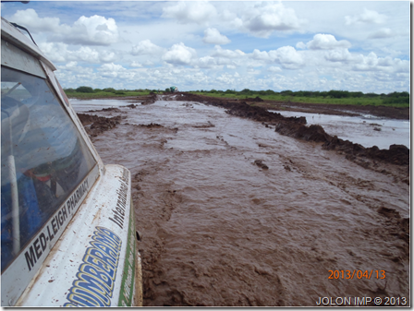

***The 20 or so kilometres had taken all of about five hours. So with the Imp front end in a broken shape we decided to stay in Turbi to carry out the necessary repairs and plan our way forward.***

As the old maxim states; **“a bad day on the road is better than a good day at the office”**

With the front end of the Imp rebuilt in searing heat at the Turbi Police compound without the tiniest bit of shelter we settled down to a solid night’s sleep to the sounds of a very close by hyena. On inspection the following morning we found the hyena footprints only about 50 meters from our tent.

Reports that the road towards Moyale that we needed to negotiate was still in desperate shape and in spite of another full day of blazing sunshine and a decent drying wind the road was too far gone to be in any condition to negotiate with anything but a Unimog or better. We went to plan X. Through the extremely hospitable and helpful Kenyan Police who had become our hosts, we established that there was a truck that had just about enough free space to accommodate our Imp and they were headed to Moyale. We struck a deal – an expensive deal – and the truck was our Hell road redemption. Only problem, the truck had to come through the self same route that had all but wrecked our Imp the previous day. What scuppered his chances however was the fact that yet another truck had been stuck there for days already and it prevented Brian our truck saviour from getting past! So again we had to exercise extreme patience, waiting around for a truck that we knew was coming but did not know when and all the time the Coventry clock was tick tocking!

Our patience was duly rewarded and at 17h30 that afternoon with Imp aboard Brian’s cattle truck and Geoff and I perched on the crossbars on top of the truck we bounced trundled across the Kenyan Hell track.

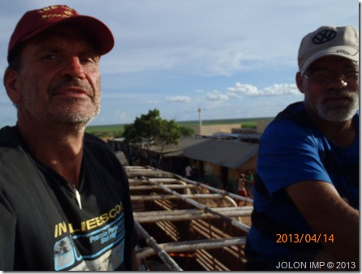

Finally even Brian’s mighty Mitsubishi truck had to succumb to the mud track and at near midnight he took his place at the back of a queue of no less than eleven transport trucks who would only attempt the crossing of a particular flooded area in daylight for fear of failure. Failure at this point, 60 kilometres from the nearest habitation was not a good option so even though we had to sleep in the back of the cattle truck along with another 25 others millions of mozzies, very suspicious looking bugs AND yet a further delay, we had no choice and secretly we were glad that we were in the hands of wise truckers.

The following morning was bathed in bright sunshine but with massive cloud build-up on the horizon and I was very keen to get going but had to wait for the truckers to give the all clear to attempt the crossing. Eleven miracles saw the eleven trucks make it through without stumbling, although there were some very close calls.

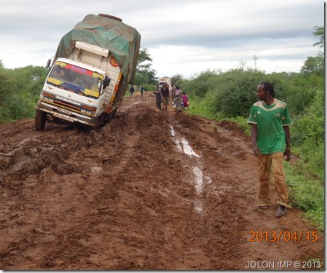

The trip through Ethiopia getting used to driving on the wrong side of the road was easy by comparison and even the stone throwing youths and the bothersome begging Police didn’t get us down. What we did enjoy was the cheap and good food and the mostly better roads apart from the few hundreds kilos of road repair secondary gravel roads that we had to deal with.

A surprise for us were the amount of people, just people, who wandered around with AK47 assault rifles slung over their shoulders, especially in the southern part of Ethiopia.

More car repairs in Addis Ababa, this time the roof rack restructured as all four legs had been broken off on the dirt roads. April in Addis is dry season, but guess what? we had some more rain, serious rain!

Addis to Bahir Dar in the north of Ethiopia and on to Sudan saw us go up to over 3000 metres above sea-level and back down again in sometimes very short distances. No Wonder the Ethiopians can develop such fantastic Olympic runners! Just going to the shops of church or school there must build such stamina and muscles, running against normal human beings would be a cinch!

At one stage, the climb was so steep that at 6 kilometres per hour in extreme heat our little car was overheating necessitating in our stopping every five minutes or so for at least ten to fifteen minutes to let it cool down again and then a serious handbrake start on an impossible uphill. So rather than risk destroying our little 875cc mill, we decided to flag down a passing tipper truck. The truck was actually going so slow that we could have hitched on to it without him even stopping. But in spite of his slow pace, he towed us slowly and safely out of the Rift Valley and we were on our own steam again.

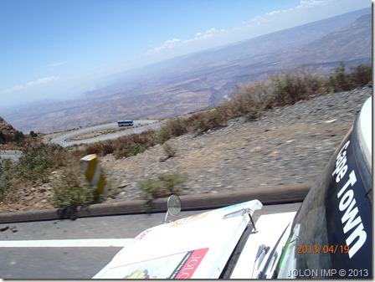

But we believe the damage was done! In spite of successfully covering massive distances from Addis all the way to Wad Medini in an effort to get to Khartoum to finalise our complicated ferry for passengers and barge for the car from Sudan to Egypt we were carrying a time bomb of a mechanical failure that only manifested as we arrived in Wad Medini after midnight on the Saturday, three days before the weekly ferry was due to leave for Egypt!

A cold shower and straight to bed well after midnight in the Wad Medini International Hotel and out at 05h00 to head into Khartoum before the early morning traffic. FAIL! As we left town the gear change went from troublesome to seriously worrisome and an urgent examination with technical text messages to my friends in South Africa to help us understand our problem and to try to help us out of our predicament. Well a complete flush bleed of the clutch slave did not help so we removed it, stripped it and found it to be A ok which left us to conclude that our problem was in fact a more challenging one. So with the slave back in place, we crash geared our way to Khartoum, amidst heavy traffic, driving on the wrong side of the road, in already blazing heat in spite of it still being early morning and being stopped at numerous police checks. This was an extremely challenging two hundred kilo trip, but in the end we made it to our destination, the Blue Nile Yacht club. With the car parked and before the engine spun to a halt Geoff had spotted where we should set up our workshop and within fifteen minutes we had the Imp ready for major surgery.

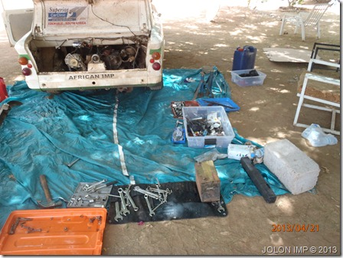

the clutch was badly worn but not yet slipping, the pressure plate however had collapsed. Now here is another miracle that helped to continue; ***as part of our spares we had packed a brand new clutch AND matching pressure plate!*** So without breakfast or lunch and after a troublesome clutchless morning drive, two non mechanics took out the Imp engine, replaced the clutch and pressure plate and put it all back together again. Unfortunately, while testing the new clutch after assembly we discovered yet another problem; the one rubber rotoflex coupling was completely broken. How we ever managed to drive with the coupling broken right through in three places is a mystery, in fact another miracle without a doubt!

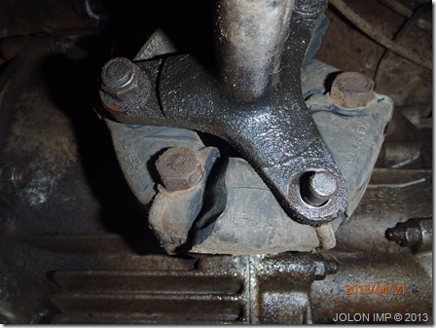

So on with one of our spare second-hand rotoflexes and a quick test-drive around the yard showed all was in order.

All was not in order!

We both showered the dust and oil and grime off our bodies and set up camp for the night; and then the clanger!

“Terence, did you tighten the bolts holding the pressure plate onto the flywheel?”

With the answer in the negative we had no option but to cancel dinner remove the engine again, this time under the street light in the yacht club and put the necessary pressure on the pressure plate by properly tightening the bolts! Now this further delayed our meeting with the ferry ticket and car barge fixer thus making it all the more improbably that we would get place on either the barge or the passenger ferry to Egypt.

Yet another miracle! While the skies in Sudan had very little clouds, we were truly blessed to find one particular cloud with lining, not silver but a lining of solid gold!

You see while we were in the middle of engine removal number two, yet another onlooker stopped by to enquire about our trip and was intrigued by what we were doing and asked if there was anything at all that he could do to assist us, to which we first politely said “no thanks”, but a quick second thought we asked if he could direct us to an ATM so we could draw cash to pay the ferryman at Wadi Halfa. Oh, not sure if that would be possible he replied, “you see since the US sanctions we have no link with Visa or Mastercard so you will not be able to draw from our ATM’s.” He went on to say that even if we went to the bank in the morning they could also not assist us. But he said he would see if one of his friends could guide us on how to solve our problem and he would get back to us.

An hour or so later I was summoned to where he was sitting with some of his friends and he said that there was no way we would be able to get the money! So here, take this as a gift from the people of Sudan. And he handed me the 300 us dollars that we were short to pay the transport to Egypt!

Monday we covered 982 kilometres of the desert road from Khartoum to Wadi Halfa with our new clutch and not properly fastened pressure plate. We arrived at 02h00 where Mazur our Wadi Halfa fixer was waiting for us. At 07h00 the next morning the mission to acquire the berths and associated paperwork for our passage to Egypt began. I am convinced the fixer managed to accommodate us at the expense of two other tourists that he seem to have had issue with. So, counting our blessings we had the car barged away mid morning and late afternoon we secured our place on the night ferry to Aswan.

Our car and the passenger ferry docked simultaneously in Aswan although the car barge left fully eight hours before the passenger ferry.

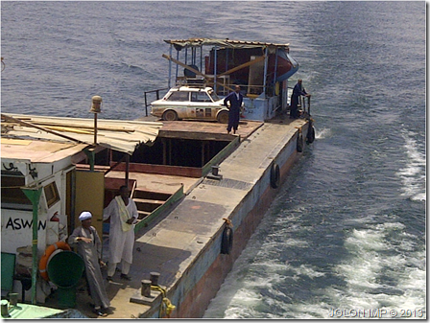

Three days of hard driving had us in Port Said where we had an interminable wait for the ferry to take us to Turkey near the Syrian border. Three days in a Port Said hotel is not a very pleasant experience but the reward of getting ourselves and our car onto the ship that would take us to the road to Coventry was worth the hardship.

With time and distance totally against us, we had to make yet another plan X. This time we redesigned our route, choosing the most direct road to England and passing up the visits to friends in Switzerland Germany and Paris where I used to work. We also reorganised our kit in the car to allow us to convert the passenger seat into a makeshift bed so that while one of us drove, the other would sleep and vice versa.

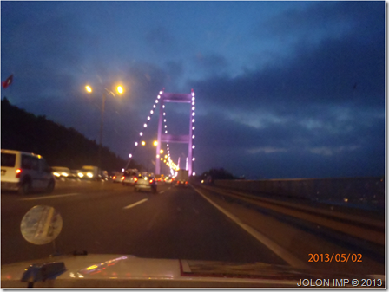

Bridge of two continents Istanbul.

Once in Turkey we wasted no time in getting to grips with the 4,500 kilos to Coventry. Near perfect roads, very light traffic and very few border delays had us making very good progress, until!!! Geoff was refused entry into Serbia. We were sent back to the Serbian embassy in Sofia to get his transit visa but on arrival in Sofia at the Serbia embassy (again in torrential rain!) we found the Embassy closed for SIX DAYS!!! We had no alternative but to re-route yet again and with the clock now in fast forward against us we felt the opportunity starting to slip away. To arrive in England after the Imp gathering had wrapped up would have been a very hollow feeling indeed. Again we dug very deep into our reserves of energy and motivation to begin the journey across the mountains towards Romania. Arriving at the Blue Danube ferry crossing we just missed the midnight ferry and decided to eat supper on the wharf and jump into our sleeping bags next to the car but out of the rain and wait for the morning ferry.

With Geoff on wheel work and me passenger seat sleeping he woke me to say he was worried about a vibration in the back. So at 07h00 on a mountain road in Romania we found to our horror that we had done yet another rotoflex coupling and this had to be changed. This robbed us of yet another hour but with the repair carried out and a good breakfast under our belts we were rejuvenated and on the road again.

Europe blurred past us between driver changes and a fleeting visit to pick up a couple of rotoflexes in Vienna from the Imp club member Peter Rosenzweig and another coffee and cake stop with family and a petrol head friend, Herbert, at a highway restaurant outside Worms in Germany.

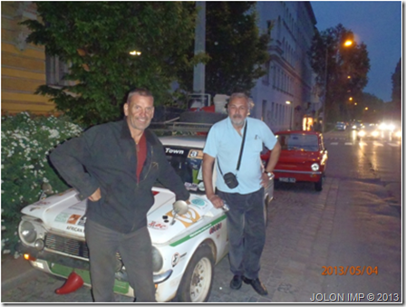

We drove through Holland and Belgium without leaving our car and only touched French soil as we purchased our cross channel ferry tickets and immediately boarded the ferry to cross the channel to England. What a culture shock to find ships departing at the exact time advertised and the efficiency of the immigration and customs officials.

Once on board we managed yet another solid hour of shut eye before arriving in Dover and the last leg of the amazing journey upon us. Geoff took us all the way to and around the London ring road and from there he took over the passenger sleep seat while I drove the final few miles to Coventry to a very special welcome in Coventry where a convoy of Imps shepherded us from the Highway to the Imp gathering. It was an extremely special moment that we will both remember with great fondness till our dying days.

