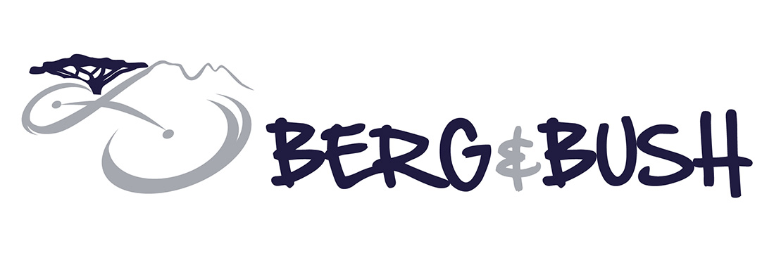

PACK LIST- FOR THE DESCENT AND GREAT TREK 3 DAY RACES PACK EVERYTHING IN ONE BIG BAG. THIS WILL BE DELIVERED TO EMSENI BY CITY COURIERS VANS FROM START
SLEEPING BAG, PILLOW,SLEEP SHEET, | TOOLBAG:  BOMBS, BOMB FITTING, TUBE, LUBE, CHAIN BREAK
BIG BAG | 1 X (COMBINATION) LOCK FOR BAG
TORCH (PETZEL HEAD TORCH) | 1 X BIKE LOCK
SWIMMING COSTUME | PUMP
TOILETRIES &TOOTHBRUSH & PASTE | BIKE
HIGH-FACTOR SUNTAN | CABLE TIES
PERSONAL VITAMINS | ENERGY BARS
LIP ICE | GOO
DEODORANT | ON RIDE DRINK
SHAMPOO & CONDITIONER | PRE-RACE DRINK & SHAKER
RAZOR | REHYDRATE
SLEEPING TABLETS & EARPLUGS | RECOVERY DRINK
TOWEL | BOTTLE BRUSH FOR CLEANING CAMELPAK
HAIR BRUSH | DISHWASH LIQUID FOR CLEANING BIKE
MIRROR | SCRUBBING BRUSH TO CLEAN BIKE
FACE WASH | HELMET
SOAP & SCRUNCHIE | POLAR/GARMIN/SUUNTO WATCH & STRAP
CHAFFING CREAM | CYCLE RAIN COAT
ICEMAN (MUSCLE MASSAGE CREAM) | OLD RAG TO CLEAN BIKE
TRACKSUIT & SWEATER | ARM & LEG WARMERS
WARM JACKET | CYCLE SHOES
RECOVERY PANTS/SOCKS | CYCLING TOPS, PANTS, SOX, GLOVES
WET WIPES | WATER BOTTLES
MONEY | CAMELPAK & BLADDER
CAMPING CHAIR (2 DAY ONLY) | SUNGLASSES
UNDERWEAR | WASHING DETERGENT & PEGS
READING BOOK | CELLPHONE & CHARGER
SLOPS | SHORTS & T-SHIRTS

